ASSIGNMENT-4
ESE – 3005
EMBEDDED SYSTEMS ARCHITECTURE 2

Submitted to :
Linchan Wang
Submitted by:
Gurvinder Singh(748418)

- Prepare core-image-minimal on your micro-SD card
- Compilation is done by executing bitbake core-image-minimal
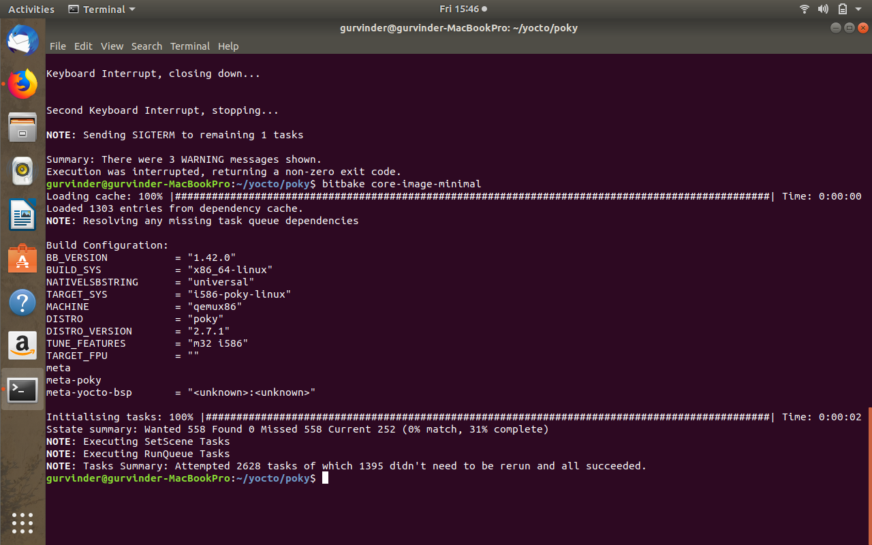

- Sdcard is used to store bootloader files.
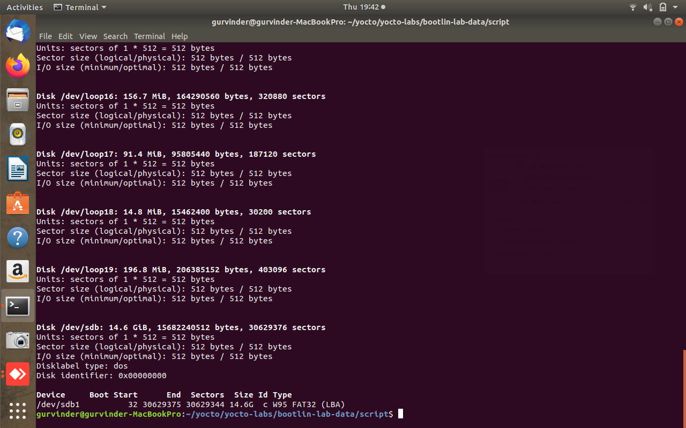

- Unmount the sdcard for setting up the partition layout.
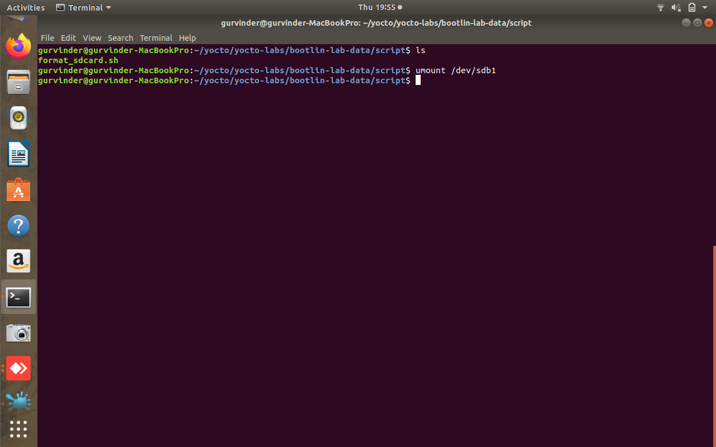

- Formatting the sdcard
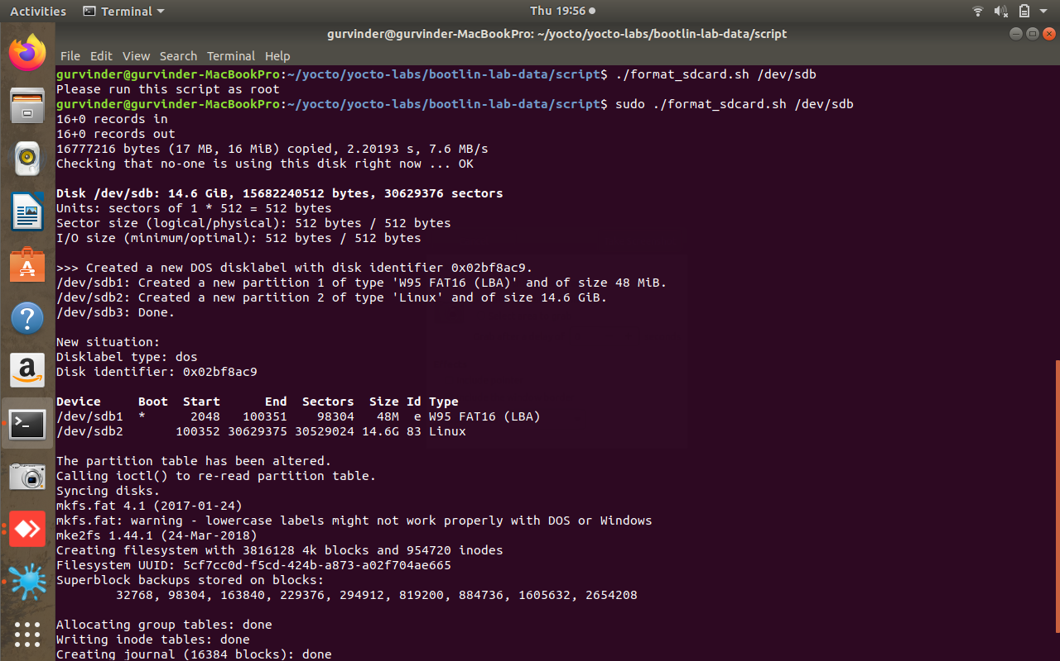

- Now image is made bootable.
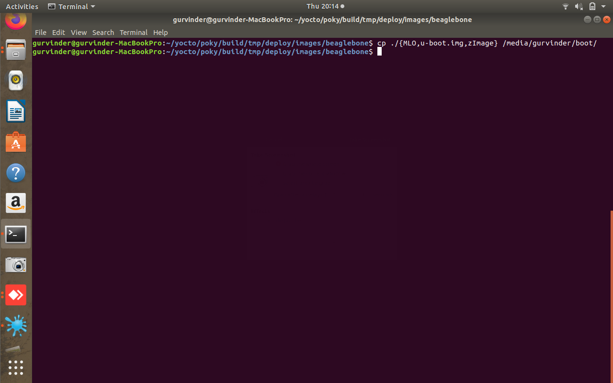

- Copy the two stages, Linux kernel image and device tree in boot partition, which was done in previous step.
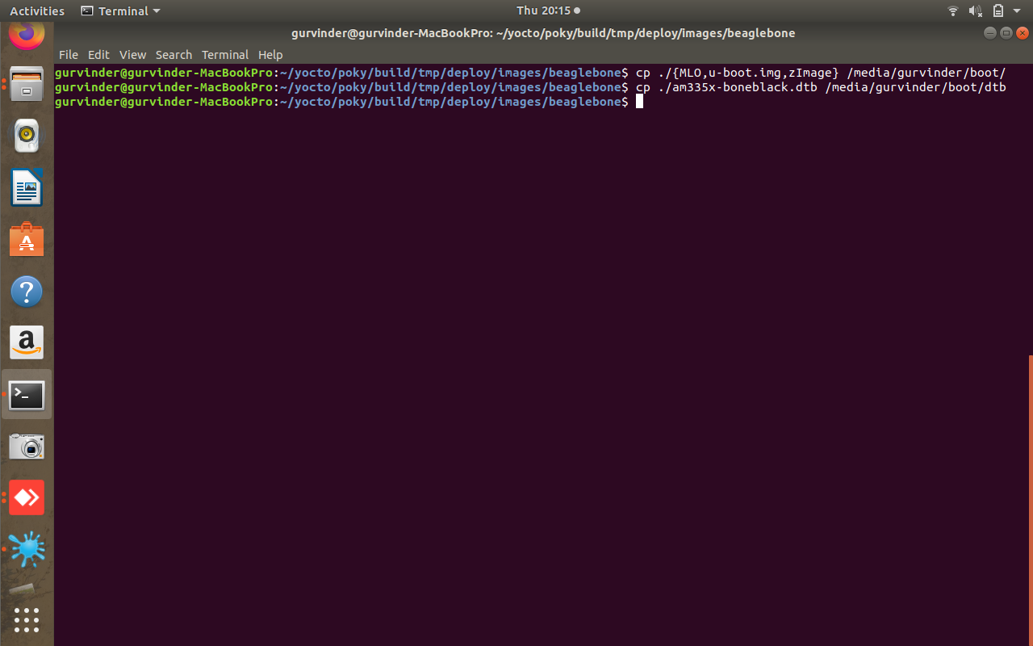

- Now in second partition, uncompressed the generated rootf.

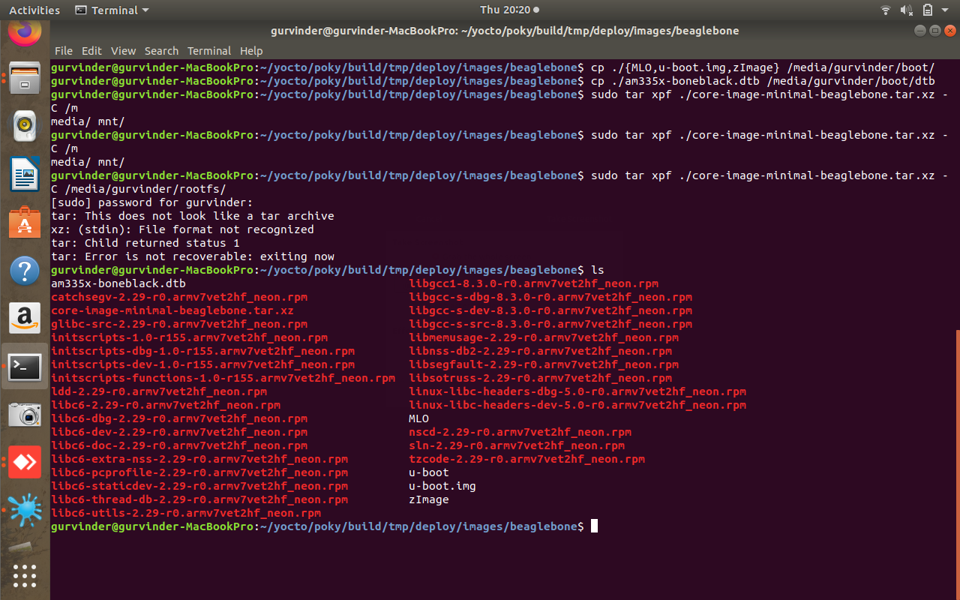

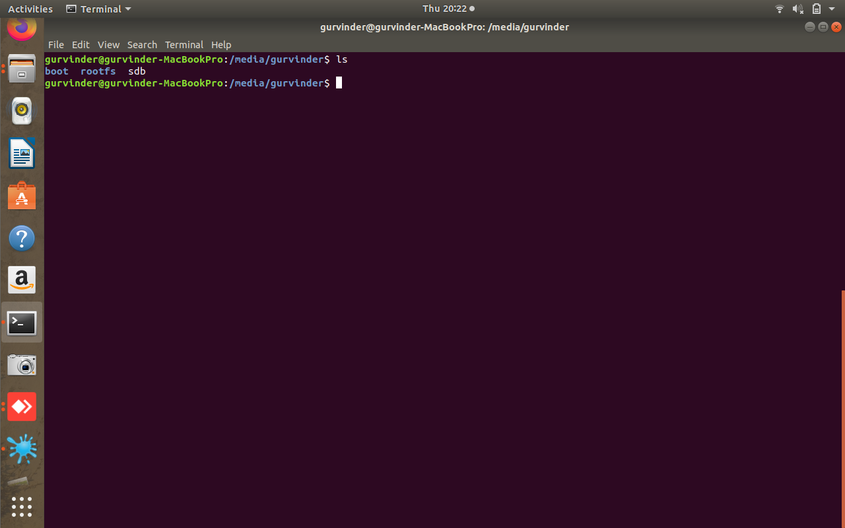

- Finally, image is being displayed.

